

A Level Summer Work

Year 11 Year 12 Transition

Due: First lesson back after summer!

Name: __________________________


This summer work is compulsory.

Your maths teacher will ask to see your work (and method) in your first maths lesson, where you will also sit a skills test to assess whether the course is right for you. Students who do not pass the test are unlikely to be successful in A level maths

Purpose
This work gives you the opportunity to practice the skills that will be required to start A Level Mathematics successfully and identify any areas where you may need to spend additional time. We want to ensure you do not feel overwhelmed when you begin your Sixth Form studies.

You have done well in your GCSE mathematics course so we have high expectations of your algebra and number skills. Now, as an A level student, we have very high expectations for the effort you will put into the course, only through an excellent attitude to learning and work ethic can students succeed in A level maths; use this summer work as an example of the effort you plan to put into the course.

These websites may be useful
- vle.mathswatch.com (ask us for a login if you are new to Dene Magna)
- www.mathcentre.ac.uk/students/topics
- www.physicsandmathstutor.com

We hope that you will use this introduction to give you a good start to you’re a Level work and that it will help you enjoy and benefit from the course.

Enjoy your summer break.

Contents:

Indices . . . . . . . . . . . 3
Surds . . . . . . . . . . . 5
Expanding and Factorising Single Brackets . . . . . 9
Solving Linear Equations . . . . . . . . 11
Rearranging Formulae . . . . . . . . . 14
Solving Linear Simultaneous Equations . . . . . . 16
Expanding and Factorising Double Brackets . . . . . 20
The Quadratic Formula . . . . . . . . 23
Completing the Square . . . . . . . . 26
Solving Nonlinear Simultaneous Equations . . . . . 29
Expanding Triple Brackets . . . . . . . . 33

Laws of Indices

Things to remember:
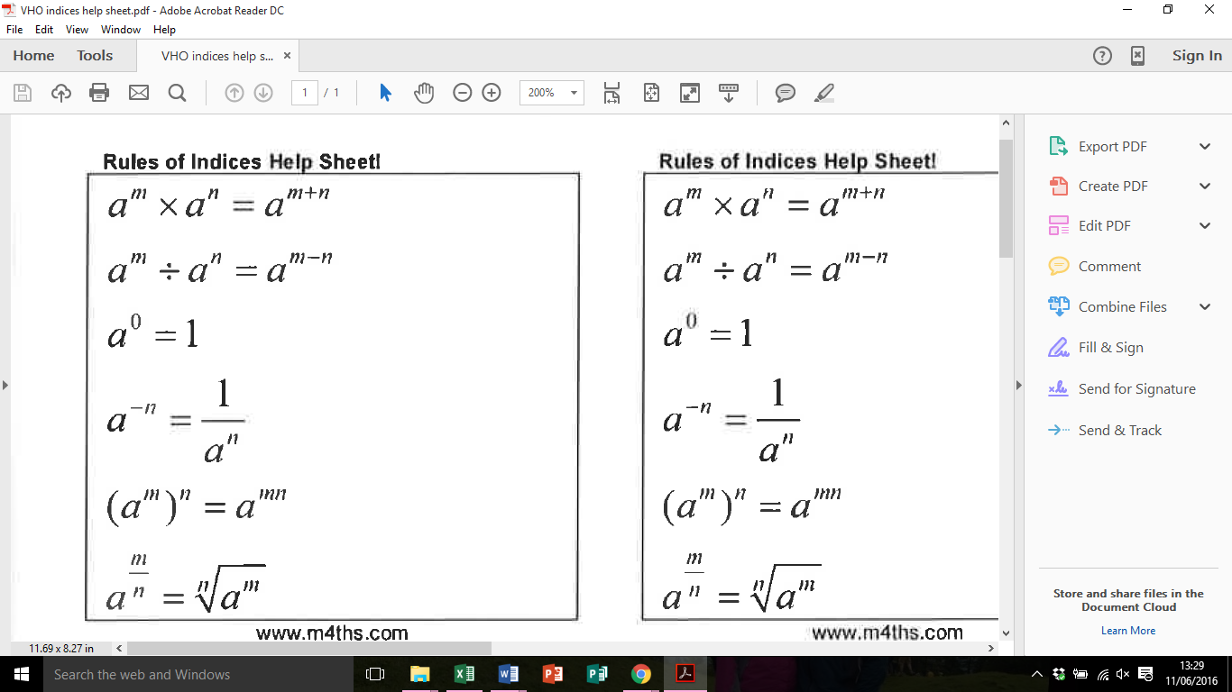

Questions:
1. (a) Simplify m⁵ ÷ m³

……………………………………
(1)
(b) Simplify 5x⁴y³ × x²y

……………………………………
(2)
(Total for Question is 3 marks)

2. Write these numbers in order of size.
Start with the smallest number.

…...........................................................................................................................................
(Total for Question is 2 marks)

3. Write down the value of 125
……………………………………
(Total for question is 1 mark)

4. (a) Write down the value of 10^{–1}

……………………………………
(1)
(b) Find the value of

……………………………………
(2)
(Total for Question is 3 marks)

5. (a) Find the value of 5°
……………………………………
(1)
(b) Find the value of ${27}^{1/3}$
……………………………………
(1)
(c) Find the value of 2⁻³

……………………………………
(1)
(Total for Question is 3 marks)

6. (a) Write down the value of ${27}^{1/3}$
……………………………………
(1)
(b) Find the value of ${27}^{{-1}/2}$

……………………………………
(2)
(Total for Question is 3 marks)

7. (a) Write down the value of
……………………………………
(1)
(b) Find the value of 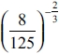
……………………………………
(2)
(Total for question = 3 marks)

8. (a) Write down the value of 6⁰
……………………………………
(1)
(b) Work out 64

……………………………………
(2)
(Total for question = 3 marks)

Surds

Things to remember:
- √ means square root;
- To simplify surds, find all its factors;
- To rationalise the denominator, find an equivalent fraction where the denominator is rational.

Questions:
1. Work out
$\frac{(5 + \sqrt{3})(5- \sqrt{3})}{\sqrt{22}}$
Give your answer in its simplest form.

……………………………………
(Total 3 marks)

2. (a) Rationalise the denominator of $\frac{1}{\sqrt{3}}$

……………………………………
(1)
(b) Expand $(2+ \sqrt{3})(1+ \sqrt{3})$
Give your answer in the form $a+b\sqrt{3}$ where a and b are integers.

……………………………………
(2)
(Total 3 marks)
3. (a) Rationalise the denominator of $\frac{1}{\sqrt{7}}$

……………………………………
(2)
(b) (i) Expand and simplify ${(\sqrt{3}+ \sqrt{15})}^{2}$
Give your answer in the form $a+b\sqrt{3}$ where a and b are integers.

……………………………………

(ii) All measurements on the triangle are in centimetres.
ABC is a right-angled triangle.
k is a positive integer.

Find the value of k.

k = ……………………………………
(5)
(Total 7 marks)

4. Expand and simplify $(\sqrt{3}- \sqrt{2})(\sqrt{3}- \sqrt{2})$

……………………………………
(Total 2 marks)

5. (a) Write down the value of ${49}^{1/2}$
……………………………………
(1)
(b) Write $\sqrt{45}$ in the form $k\sqrt{5}$, where k is an integer.

……………………………………
(1)
(Total 2 marks)

6. Write $\frac{\sqrt{18} + 10}{\sqrt{2}}$ in the form $a+b\sqrt{2}$ where a and b are integers.

a = ……………………………………

b = ……………………………………
(Total 2 marks)

7. Expand and simplify $(2+ \sqrt{3})(7- \sqrt{3})$
Give your answer in the form $a+b\sqrt{3}$ where a and b are integers.

……………………………………
(Total 3 marks)

8. Rationalise the denominator of $\frac{(4 + \sqrt{2})(4 - \sqrt{2)}}{\sqrt{7}}$
Give your answer in its simplest form.

……………………………………
(Total for question = 3 marks)

9. Show that $\frac{(4 - \sqrt{3})(4 + \sqrt{3})}{\sqrt{13}}$ simplifies to $\sqrt{13}$

(Total for question = 2 marks)

Expanding and Factorising (Single Brackets)

Things to remember:
- Expand brackets means to multiply what is outside the bracket with everything inside the bracket.
- Factorising is the opposite of expanding – put the HCF outside the brackets to factorise fully.

Questions:
1. (a) Expand 5(m + 2)

...........................................................
(1)
(b) Factorise y² + 3y

...........................................................
(1)
(c) Simplify a⁵ × a⁴

...........................................................
(1)
(Total for Question is 3 marks)

2. (a) Expand 2m(m + 3)

...........................................................
(1)
(b) Factorise fully 3xy² − 6xy

...........................................................
(2)
(Total for Question is 3 marks)

3. (a) Expand 3(x + 4)

...........................................................
(1)
(b) Expand x(x² + 2)

...........................................................
(2)
(c) Factorise x² − 6x

...........................................................
(1)
(Total for Question is 4 marks)

4. (a) Expand and simplify 5(x + 7) + 3(x – 2)

...........................................................
(2)
(b) Factorise completely 3a²b + 6ab²

...........................................................
(2)
(Total for Question is 4 marks)

5. (a) Expand 3(2y – 5)

...........................................................
(1)
(b) Factorise completely 8x² + 4xy

...........................................................
(2)
(Total for Question is 3 marks)

6. (a) Factorise 3x + 6

...........................................................
(1)
(b) Expand and simplify 5(y − 2) + 2(y − 3)
...........................................................
(2)
(Total for Question is 3 marks)

7. (a) Factorise 4x + 10y

...........................................................
(1)
(b) Factorise x² + 7x

...........................................................
(1)
(Total for Question is 2 marks)
Solving Equations

Things to remember:
- “Solve” means to find the value of the variable (what number the letter represents).
- The inverse of + is – and the inverse of x is ÷
- Work one step at a time, keeping you = signs in line on each new row of working.

Questions:
1. Solve 4x + 3 = 19

x =………………………
(Total 2 marks)

2. (a) Solve 6x – 7 = 38

x = .................................
(2)
(b) Solve 4(5y – 2) = 40

y = .................................
(3)
(Total 5 marks)

3. Solve 5(2y + 3) = 20

y = .................................
(Total 3 marks)

4. (a) Solve 7x + 18 = 74

x = ………………………
(2)
(b) Solve 4(2y – 5) = 32

y = ………………………
(2)
(c) Solve 5p + 7 = 3(4 – p)

p = ………………………
(3)
(Total 7 marks)

5. (a) Solve 7p + 2 = 5p + 8

p = ............................
(2)
(b) Solve 7r + 2 = 5(r – 4)

r = ...........................
(2)
(Total 4 marks)

6. Solve
4y + 1 = 2y + 8

y =………………………
(Total 2 marks)

7. Solve 4y + 3 = 2y + 8

y = ..............................
(Total 2 marks)

Rearranging Formulae

Things to remember:
- Firstly decide what needs to be on its own.
- Secondly move all terms that contain that letter to one side. Remember to move all terms if it appears in more than one.
- Thirdly separate out the required letter on its own.

Questions:
1. Make u the subject of the formula
D = ut + kt2

u = …................................
(Total 2 marks)

2. (a) Solve 4(x + 3) = 6

x = ………………….
(3)
(b) Make t the subject of the formula v = u + 5t

t = ………………….
(2)
(Total 5 marks)

3. (a) Expand and simplify
(x – y)²

….............................................
(2)
(b) Rearrange a(q – c) = d to make q the subject.

Q = ….......................................
(3)
(Total 5 marks)

4. Make x the subject of
5(x – 3) = y(4 – 3x)

x = …..................................
(Total 4 marks)

5.
Rearrange the formula to make a the subject.

A =…..................................
(Total 4 marks)
6.
Make x the subject of the formula.

X =….............................
(Total 4 marks)

Linear Simultaneous Equations

Things to remember:
- Scale up (if necessary)
- Add or subtract (to eliminate)
- Solve (to find x)
- Substitute (to find y) (or the other way around)

Questions:
*1. The Singh family and the Peterson family go to the cinema.
The Singh family buy 2 adult tickets and 3 child tickets.
They pay £28.20 for the tickets.
The Peterson family buy 3 adult tickets and 5 child tickets.
They pay £44.75 for the tickets.
Find the cost of each adult ticket and each child ticket.

(Total for question = 5 marks)

2. Solve the simultaneous equations
3x + 4y = 5
2x – 3y = 9
x = …........................................................

y = …….....................................................
(Total for Question is 4 marks)

3. Solve the simultaneous equations
4x + 7y = 1
3x + 10y = 15

x = …........................................................

y = …….....................................................
(Total for Question is 4 marks)
4. Solve
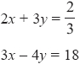
x = …........................................................

y = …….....................................................
(Total for Question is 4 marks)

5. Solve the simultaneous equations
4x + y = 25
x – 3y = 16

x = …........................................................

y = …….....................................................
(Total for Question is 3 marks)

6. Solve the simultaneous equations
3x – 2y = 7
7x + 2y = 13

x = …........................................................

y = …….....................................................
(Total for Question is 3 marks)

7. A cinema sells adult tickets and child tickets.
The total cost of 3 adult tickets and 1 child ticket is £30
The total cost of 1 adult ticket and 3 child tickets is £22
Work out the cost of an adult ticket and the cost of a child ticket.
adult ticket £…........................................................
child ticket £…........................................................
(Total for question = 4 marks)

*8. Paper clips are sold in small boxes and in large boxes.
There is a total of 1115 paper clips in 4 small boxes and 5 large boxes.
There is a total of 530 paper clips in 3 small boxes and 2 large boxes.
Work out the number of paper clips in each small box and in each large box.
(Total for Question is 5 marks)
Expand and Factorise Quadratics

Things to remember:
- Use FOIL (first, outside, inside, last) or the grid method (for multiplication) to expand brackets.
- For any quadratic ax² + bx + c = 0, find a pair of numbers with a sum of b and a product of ac to factorise.

Questions:
1. Expand and simplify (m + 7)(m + 3)

……………………………………
(Total for question = 2 marks)

2. (a) Factorise 6 + 9x
……………………………………
(1)
(b) Factorise y² – 16
……………………………………
(1)
(c) Factorise 2p² – p – 10

……………………………………
(2)
(Total for Question is 4 marks)

3. Solve, by factorising, the equation 8x² – 30x – 27 = 0
……………………………………
(Total for Question is 3 marks)

4. Factorise x² + 3x – 4
……………………………………
(Total for question is 2 marks)

5. Write x² + 2x – 8 in the form (x + m)² + n where m and n are integers.

……………………………………
(Total for question is 2 marks)

6. (a) Expand 4(3x + 5)

……………………………………
(1)
(b) Expand and simplify 2(x – 4) + 3(x + 5)

……………………………………
(2)
(c) Expand and simplify (x + 4)(x + 6)

……………………………………
(2)
(Total for Question is 5 marks)

7. (a) Factorise x² + 5x + 4

……………………………………
(2)
(b) Expand and simplify (3x −1)(2x + 5)

……………………………………
(2)
(Total for Question is 4 marks)

8. (a) Expand 3(2 + t)
……………………………………
(1)
(b) Expand 3x(2x + 5)
……………………………………
(2)
(c) Expand and simplify (m + 3)(m + 10)

……………………………………
(2)
(Total for Question is 5 marks)

9. (a) Factorise x² + 7x

……………………………………
(1)
(b) Factorise y² – 10y + 16

……………………………………
(2)
*(c) (i) Factorise 2t² + 5t + 2

……………………………………
(ii) t is a positive whole number.
The expression 2t² + 5t + 2 can never have a value that is a prime number.
Explain why.

………..................................................................................................................

………..................................................................................................................

………..................................................................................................................
(3)
(Total for Question is 6 marks)

Using the Quadratic Formula

Things to remember:
- For any quadratic, ax² + bx + c = 0,
$$x=\frac{-b±\sqrt{b^{2}-4ac}}{2a}$$

Questions:
1. Solve 3x² + 7x – 13 = 0
Give your solutions correct to 2 decimal places.

x = ................................ or x = ................................
(3 marks)

2. Solve the equation
2x² + 6x – 95 = 0
Give your solutions correct to 3 significant figures.

x = ...................................... or x = ......................................
(3 marks)

3. Solve x² + 3x - 5 = 0
Give your solutions correct to 4 significant figures.

......................................
(3 marks)
4. Solve this quadratic equation.
x² – 5x – 8 = 0
Give your answers correct to 3 significant figures.

x = .....................................or x = .....................................
(3 marks)

5. (a) Solve x² – 2x – 1 = 0
Give your solutions correct to 2 decimal places.

.......................................................
(3)
(b) Write down the solutions, correct to 2 decimal places, of 3x² – 6x – 3 = 0

.......................................................
(3)
(6 marks)

6. (a) Solve x² + x + 11 = 14
Give your solutions correct to 3 significant figures.

......................................................
(3)
y = x² + x + 11 The value of y is a prime number when x = 0, 1, 2 and 3
The following statement is not true.
‘y = x² + x + 11 is always a prime number when x is an integer’
(b) Show that the statement is not true.

.....................................................................................................................................

.....................................................................................................................................
(1)
(4 marks)

Completing the Square

Things to remember:
- To complete the square:
  - Halve the coefficient of x.
  - Put in brackets with the x and square the brackets.
  - Subtract the half-coefficient squared.
  - Don’t forget the constant on the end!
  - Simply.
- For (x - p)² + q = 0, the turning point is (p, q).

Questions:
1. (i) Sketch the graph of f(x) = x² − 5x + 10, showing the coordinates of the turning point
and the coordinates of any intercepts with the coordinate axes.
(ii) Hence, or otherwise, determine whether f(x + 2) − 3 = 0 has any real roots.
Give reasons for your answer.

(Total for question = 6 marks)

2. (a) Write 2x² + 16x + 35 in the form a(x + b)² + c where a, b, and c are integers.
...........................................................
(3)
(b) Hence, or otherwise, write down the coordinates of the turning point of the graph
of y = 2x² + 16x + 35
...........................................................
(1)
(Total for question = 4 marks)

3. The expression x² – 8x + 21 can be written in the form (x – a) ² + b for all values of x.
(a) Find the value of a and the value of b.

a = ...........................................................

b = ...........................................................
(3)
The equation of a curve is y = f(x) where f(x) = x² – 8x + 21
The diagram shows part of a sketch of the graph of y = f(x).
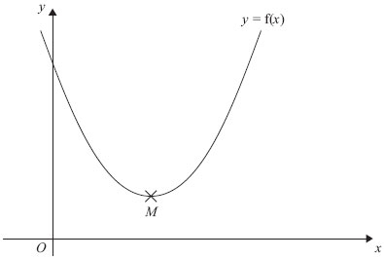
The minimum point of the curve is M.
(b) Write down the coordinates of M.

...........................................................
(1)
(Total for Question is 4 marks)

Nonlinear Simultaneous Equations

Things to remember:
- Substitute the linear equation into the nonlinear equation.
- Rearrange so it equals 0.
- Factorise and solve for the first variable (remember there will be two solutions).
- Substitute the first solutions to solve for the second variable.
- Express the solution as a pair of coordinate where the graphs intersect.

Questions:
1. Solve the equations
x² + y² = 36
x = 2y + 6

...........................................................
(Total for Question is 5 marks)

3. Solve the simultaneous equations
x² + y² = 25
y = 2x + 5

x = . . . . . . . . . . . . . . and y = . . . . . . . . . . . . . .
or
x = . . . . . . . . . . . . . . and y = . . . . . . . . . . . . . .
(Total for Question is 6 marks)

4. Solve the simultaneous equations x² + y² = 9
x + y = 2
Give your answers correct to 2 decimal places.

x = . . . . . . . . . . . . . . . y = . . . . . . . . . . . . . . .

or x = . . . . . . . . . . . . . . . y = . . . . . . . . . . . . . . .
(Total for Question is 6 marks)

5. Solve algebraically the simultaneous equations
x² + y² = 25
y − 2x = 5

...........................................................
(Total for Question is 5 marks)

Expanding more than two binomials

Things to remember:
- Start by expanding two pair of brackets using the grid or FOIL method.
- Then expand the third set of brackets.
- Use columns to keep x³, x² etc in line to help with addition.

Questions:
1. Show that
(x − 1)(x + 2)(x − 4) = x³ - 3x² - 6x + 8
for all values of x.

...........................................................
(Total for question is 3 marks)

2. Show that
(3x − 1)(x + 5)(4x − 3) = 12x³ + 47x² − 62x + 15
for all values of x.

...........................................................
(Total for question is 3 marks)
3. Show that
(x - 3)(2x + 1)(x + 3) = 2x³ + x² − 18x - 9
for all values of x.

...........................................................
(Total for question is 3 marks)

4. (2x + 1)(x + 6)(x - 4) = 2x³ + ax² + bx – 24
for all values of x, where a and b are integers.
Calculate the values of a and b.

a = ...........................................................

b = ...........................................................
(Total for question is 4 marks)

