

Year 7 Tutor Virtual Evening
If you have any issues or unable to get on line then please contact reception and we will be happy to book your appointments for you.
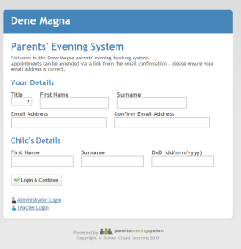
Thursday 5 October 2023
Complete the details on the screen and this will take you through to the appointments screen.
NB: Please register on the system ASAP, this will allow you to receive emails when teachers make appointments with you
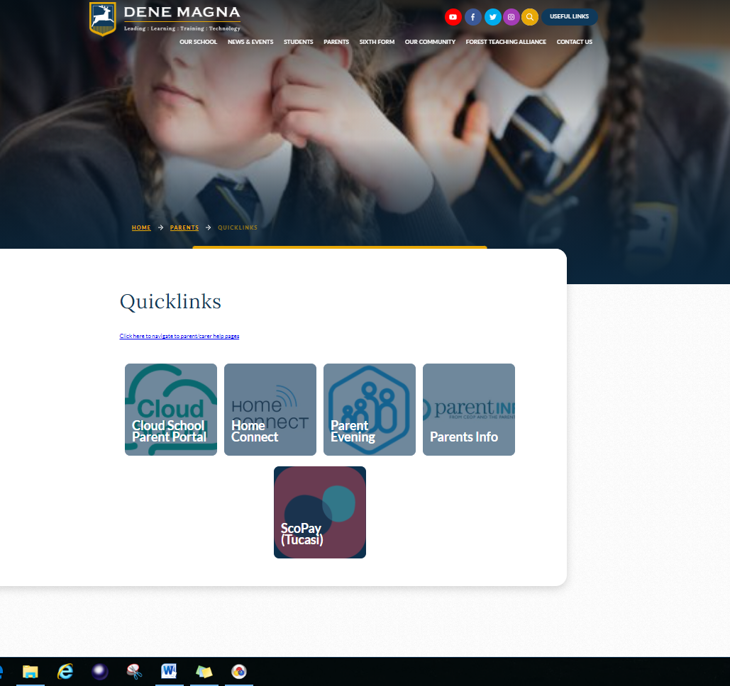
Appointments are made on line. There is a link to the system from the school website.
Click on the Useful Links tab
Then the ‘Parents Evening System’ link

