Key Stage 4
Courses
2024 - 2026
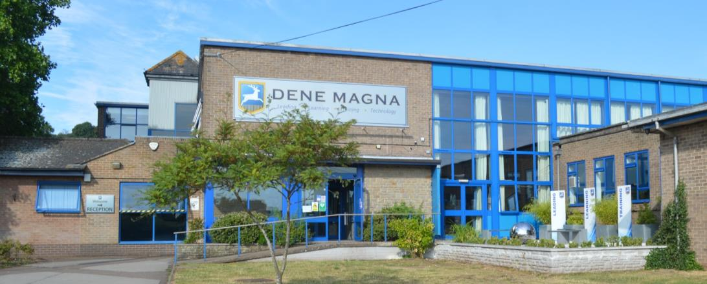

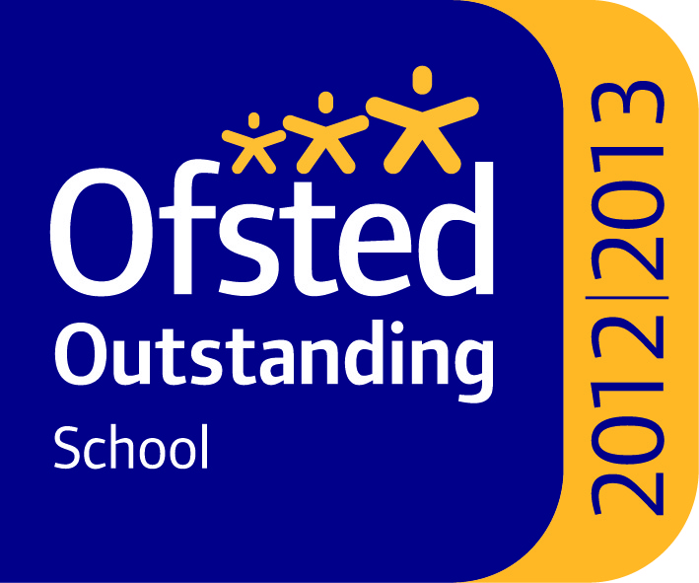
Information for
Year 9 Students


Dear Student
In September you will be moving into Year 10 and starting courses that will lead to your examinations in the summer of 2026.
The qualifications that you follow over the next two years will put you in a position where you are best prepared to move on to the next stage of your education or training. To meet those challenges you will study a broad range of subjects, which will give you the best chance of making a success of your future life and career. You will want to think about how the choices you make meet your specific needs, interests and career aspirations.
This booklet, and the options’ process over the next few weeks, is designed to help you make your choices. However, it only gives a brief outline of each subject and I encourage you to research more widely into what each of the options involve. You should also ask subject teachers about what the course includes and whether you would be well suited to it.
The way that school performance is measured is explained in detail in this booklet. This system is designed to encourage students to study a suite of subjects that the Government has defined as the ‘Gold Standard’, and one that all students should strive to achieve. To make the best progress as defined in the ‘Progress 8’ Measure, and to achieve the English Baccalaureate, students will need to have achieved at least a grade 5 in the following GCSE subjects:
- English
- Maths
- Science
- A Modern Foreign Language
- Either Geography or History.
As a school we recommend that you take account of this guidance in your choice of study.
Make your choices wisely. You are making choices that will resonate throughout your future life and career, so think beyond short term issues, such as what your friends are doing or a particular teacher you like. Talk to your parents/carers, other family members, your tutor and subject teachers and then work out what will be best for you.
Whatever your choices, it is essential that you work hard over the next two years, creating a strong platform for your future learning and life. I am confident that you will rise to this challenge and I look forward to celebrating your success with you.
Yours sincerely

Fred Mitchell, Deputy Headteacher
Letter from the Deputy Headteacher |  | 2
Contents |  | 3
Important Dates |  | 4
Guide to Qualifications and Performance Measures |  | 5-7
Core Subjects |  | 8-9
Introduction to Options Subjects |  | 10
 | Art and Design | 11
 | Business Studies | 12
 | Child Development | 13
 | Computer Science | 14
 | Technical Award in IT | 15
 | Drama | 16
 | Hospitality & Catering | 17
 | French | 18
 | Spanish | 19
 | Choosing a Humanities Subject | 20-21
 | Geography | 22
 | History | 23
 | Religious Studies | 24
 | Sport Studies | 25
 | GCSE PE | 26
 | Music | 27
 | Design and Technology- Textiles | 28
 | Technical Award in Product Engineering | 29
Frequently Asked Questions |  | 30
How to Complete Your Options’ Form |  | 31
What is in this booklet?

IMPORTANT DATES
- Year 9 Options’ Evening: Thursday January 18th 2024, 5:30pm-7:30pm
This evening will include a talk by Mr Mitchell, as well as the opportunity to meet subject staff in our ‘Subject Fair’
- Year 9 Subject Evening Thursday February 1st 2024 4pm-7pm
This is our normal Parents’/Carers’ Evening. Appointments will be available to book online
- Deadline for preference forms: Tuesday February 6th 2024
Preference forms must be returned to Mr Mitchell, via Tutors
- Students and Parents/Carers informed of options: Summer Term 2024

Throughout the process each student will be guided by their Tutor. Each student will meet with their Tutor and have the opportunity to discuss, and ask, specific questions.
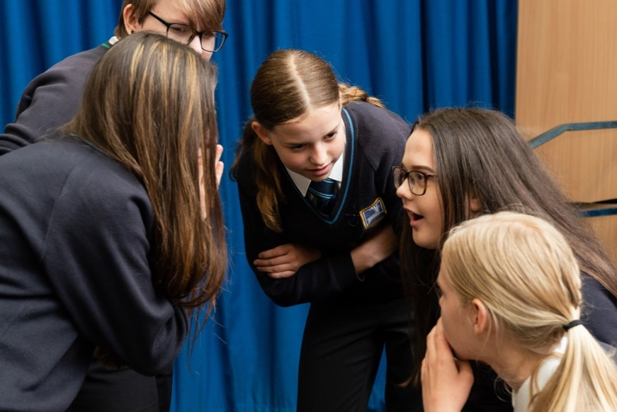

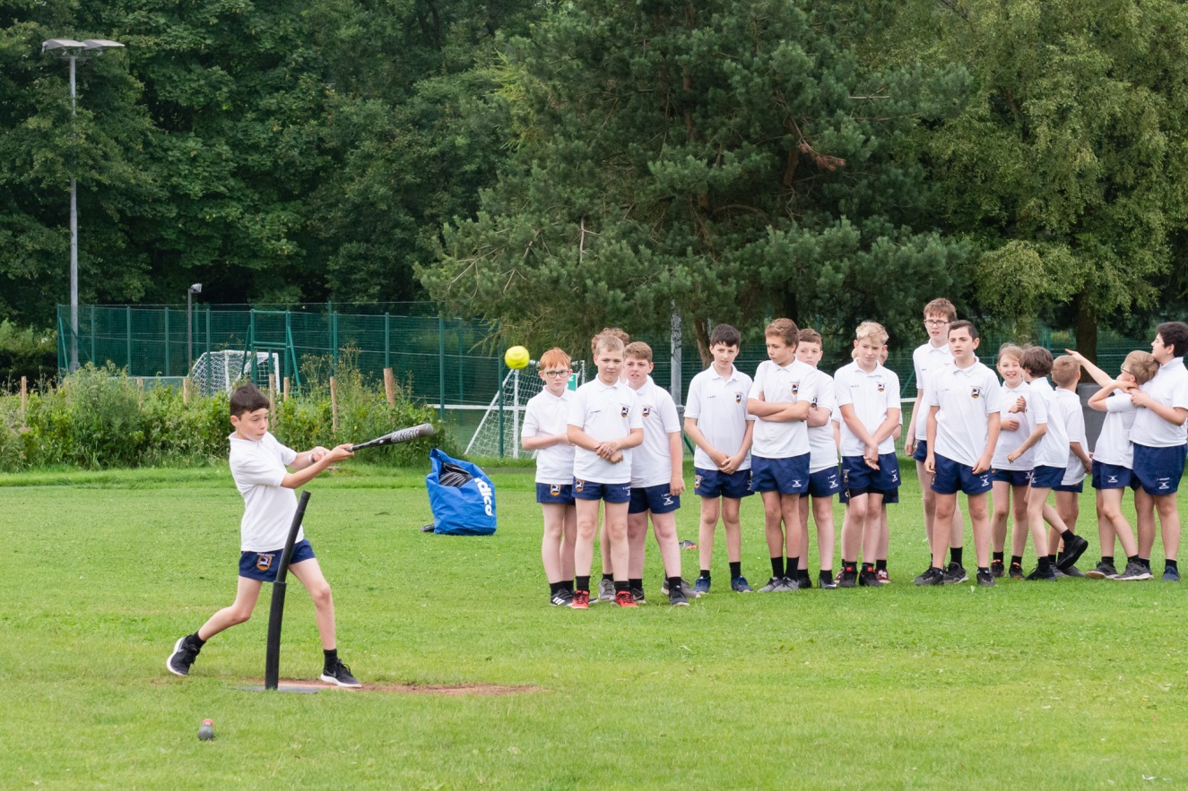
Qualifications and ‘Performance Measures’... a quick guide to what they mean
All students and schools are measured on how much progress they make from when they start in Year 7 (KS2 Prior Attainment) to when they complete their exams in Year 11 (Attainment 8). This measure is known as the ‘Progress 8’ measure.
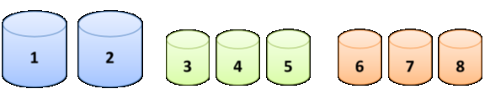
The measure is designed to encourage all students to study a broad and balanced curriculum. It is based on students’ progress across eight subjects. For the purposes of the measure, subjects are grouped into three ‘pots’, as shown in the diagram below:
English*
Double Weighted
Maths
Double Weighted
EBacc qualifications
Sciences, Geography, History and Languages
‘Open Group’
Remaining EBacc qualifications and other approved qualifications (this includes BTec qualifications)
*Higher score of English Language or English Literature will be double-weighted
The Attainment 8 Score and the Progress 8 Measure

Each student will receive an ‘Attainment 8’ score, which will always be determined by dividing the total points achieved (English and Maths will be doubled) and dividing by 10, regardless of how many qualifications your daughter/son studies. This means that if any of the ‘pots’ are not full this will count against that student.
The Progress 8 measure is then worked out by looking at each student’s KS2 Prior Attainment (their Attainment at the end of KS2) and comparing the progress they have made with all other students across the country who achieved the same KS2 score as them.
Schools will publish the average Progress 8 scores for all of the Year group as part of their ‘Headline Figures’. The other headline measures are:
- Attainment 8 – A number, which shows the average grade achieved in the Attainment 8 subjects for all students
- Basics in English and Mathematics – A measure of how many students achieved the equivilant of a grade 5+ in both English and Maths. The number of students achieving a Grade 4+ in both subjects will also be reported
- The EBacc – a measure of how many students achieved a 5 or above in Maths, English Language, two Science subjects, either Geography or History and a Language.
Obviously, it is essential that we maximise the opportunities for each student and you will see that these guidelines are integrated into how we have designed the options’ process for your son/daughter.
We know that each student is different and has different interests, abilities and aspirations. As a school, Dene Magna always encourages every student to have the highest aspirations. Below are some examples of different routes through the options’ process and the potential implications.
Student A
English*
Double Weighted
Maths
Double Weighted
EBacc qualifications
Sciences, Computer Science, Geography, History and Languages
‘Open Group’
Remaining EBacc qualifications and other approved qualifications
Studies English (Language and Literature) and Maths as part of their core subjects
Will study Science as part of their core subjects. Chooses History and Spanish in their options
Chooses Product Design and Music as their other two options (the third pot will be filled by a ‘spare’ subject from the EBacc pot)
Student A has filled all their pots and also is doing subjects that will mean they achieve the EBacc, if they gain 5+ grades.
They are now well placed to go on to study A levels and go on to Higher Education at the full range of Universities and Colleges.

Student B
English*
Double Weighted
Maths
Double Weighted
EBacc qualifications
Sciences, Geography, History and Languages
‘Open Group’
Remaining EBacc qualifications and other approved qualifications
Studies English (Language and Literature) and Maths as part of their core subjects
Will study Science as part of their core subjects. Chooses Geography as one of their options
Chooses Art, Business Studies and ICT as their other options
Student B has filled all their pots; however, they have not achieved the EBacc.
They can go on to study A levels and would still have access to University. However, some Universities may look for the EBacc as part of their entry criteria.
Student C
English*
Double Weighted
Maths
Double Weighted
EBacc qualifications
Sciences, Geography, History and Languages
‘Open Group’
Remaining EBacc qualifications and other approved qualifications
Studies English (Language and Literature) and Maths as part of their core subjects
Will study Science as part of their core subjects. Does not choose another subject from the EBacc pot
Chooses Product Engineering, Business Studies, GCSE PE and Hospitality & Catering as their other options
Student C has not filled their ‘EBacc pot’ and this will lead to a lower Progress 8 score. They have also not achieved the EBacc.
As long as they have achieved equivalent of 4+ grades or better in their English and Maths they will have access to Level 3 courses post 16 and Apprenticeships.

Changes in Grades

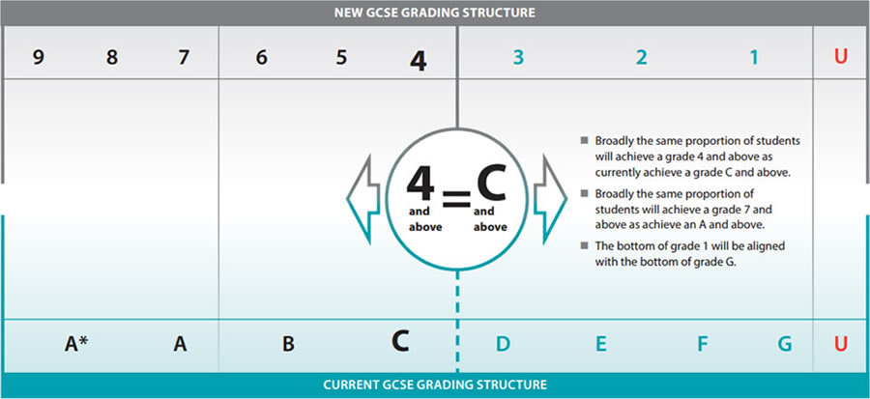
The diagram below shows how the new grades (numbers 9-1) relate to the old grades for GCSE (letters A*-G). It should be noted that the old grades do not exactly match the new grades.

Subjects that all students take
(The ‘Core’ Curriculum):
ENGLISH
ENGLISH
Students will be taught two GCSEs (GCSE Literature and GCSE Language). Both courses encourage students to be creative; to think analytically; to explore different types of writing, both fiction and non-fiction, and to broaden their understanding of the English language. Students enjoy this subject because of its exploratory nature; they can bring their thoughts to the lessons and share their ideas and opinions.
There will be two English Language exams – to be taken at the end of year eleven and two English Literature exams to be taken at the end of year eleven. Throughout the two years we will be ensuring that students are ‘exam ready’ and many of our assessments will be completed in timed conditions to prepare students for the rigours of GCSE examinations. These qualifications will be graded under the new 1-9 system.
English Language:
- Students will respond to unseen extracts from 19th, 20th and 21st century texts
- Students must compare at least two unseen texts
- In each exam students will have to respond to questions analysing these unseen texts (focusing on understanding the content, language analysis, structural analysis, writer’s attitudes and viewpoints and evaluating impact of the texts)
- In each exam students will also need to respond to a writing task and produce a piece of sustained, controlled writing for a particular audience and purpose
- 20% assessment weighting will be for spelling, sentence structure, punctuation and grammar.
Please note that Speaking and Listening is not now directly assessed as part of the GCSE, but will be certificated separately. We do still believe this to be a vital life skill and, therefore, students will still be taught speaking and listening units.
English Literature:
- Students must study a 19th century novel, a whole play by Shakespeare and a selection of poetry (including representative Romantic poetry)
- Students must compare at least two of the unseen texts (most exam boards are choosing poetry)
- The modern prose or drama text must be written by a British writer
- Exams will be closed book (i.e. no copies of the text can be taken into the exam).

MATHEMATICS
GCSE Mathematics requires study in the following areas:
- Number
- Algebra
- Geometry and measures
- Probability
- Statistics
- Ratio, proportion and rates of change
It aims to enable students to:
1. Develop fluent knowledge, skills and understanding of mathematical methods and concepts
2. Acquire, select and apply mathematical techniques to solve problems
3. Reason mathematically, make deductions and inferences and draw conclusions
4. Comprehend, interpret and communicate mathematical information in a variety of forms appropriate to the information and context.
All students in Year 10 will study Mathematics. The course leads to a GCSE qualification in one of 2 levels: Higher [4-9] or Foundation [1-5]. Assessment is through examinations: 3 papers, each an hour and a half long. A calculator is permitted in two of these papers.

Core PE
All students will continue to follow a varied programme of sporting activities throughout KS4.

Religious Studies
Students will study RS/PSHE as part of their core studies; this will not lead to an exam. Through this programme students will have the opportunity to look at a range of religions, as well as exploring responses to different moral and ethical issues that are prevalent in modern life. GCSE RS is available as part of the options process and is studied separately by students who opt for RS.

Social Studies
Students in KS4 continue to work in PSHE through their tutor sessions. There is an emphasis on work related learning, healthy living and their personal and social development.

SCIENCE
All students in Year 10 will continue to study the combined science GCSE that they started in Year 9. The majority of students will
follow the GCSE combined science course, with one class being selected to do separate sciences when moving in to Year 10 and Year 11. This will be decided using teacher feedback, performance throughout the year and the end of Year 9 exam.
• Edexcel Combination Science, a course that gives two GCSEs that covers topics from biology, chemistry and
physics
• Edexcel Separate Sciences (biology, chemistry and physics) will be offered to some students who show a flair and aptitude for the three science disciplines throughout Year 10 and perform well in the Year 10 exam.
All courses are assessed through exams at the end of Year 11. There is no controlled assessment, however,
students will complete ‘core practicals that they will need to recall in the exam.

No matter the pathway the students take, it will enable them to study A-Level sciences Post-16

Options’ Subjects
In addition to your ‘core’ curriculum, you will have the opportunity to choose other subjects that are suited to you and your interests and abilities.
The aim of the Key Stage 4 curriculum is to provide the opportunity for a broad, relevant and balanced learning experience, whilst maintaining as much individual choice as possible. This balance should ensure that the widest range of career choices is open to you in the future. Employers and Higher/Further Education establishments will look for a wide basic education, which will enable young people to develop flexibility and adaptability; essential qualities in today’s fast changing world.
A good balanced choice will include subjects that demonstrate both ‘academic’ and ‘creative’ abilities and also give you a varied ‘work style’, for example, balancing subjects that are focussed on coursework and those that put more emphasis on exams. Education should develop the whole self and every opportunity should be taken to make that self as diverse as possible.
A wise choice, taken after consultation with parents/carers, subject teachers, subject leaders and tutors, will result in a course that is tailored to your individual needs and aptitude. This will ensure that you receive a broad and balanced education, which will provide you with the widest range of opportunities at the end of Key Stage 4.
Once options’ forms are completed and processed the Leadership Group will check your choices. Prior experience shows us that the first step to success in any qualification is making sure that students are on the correct courses that match their aptitudes, needs and aspirations. Therefore, we will use our experience and knowledge, of both you and the courses that you have chosen, to help you make that wise choice.
We emphasise that whilst all attempts will be made to accommodate preferences and to run the courses as published, these cannot be guaranteed due to numbers of students choosing options and the constraints of the timetable. To help in the process students are asked to complete 5 choices. Students will be allocated 4 subjects from their 5 preferences.

GCSE Art and Design  AQA 42021/ 420222 |  |  |  |  | 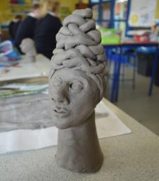
What is Involved?
- 4 projects – 3 count towards Controlled Assessment, 1 counts towards Examination
- Each project includes: Artist Research, primary sources of inspiration, photography, visual responses, final piece planning and the final piece will be completed at A2 size

How are we Assessed? |  |  |  | Grades available: |  |  | GCSE grades 9-1
- Examination:  - Controlled Assessment: |  |  | 40% 2 x 5 hrs  60% Portfolio of Work
- buy a sketchbook, folder and art supplies from the Art department at the start of the course (£15)
- work in both 2 and 3 dimensions
- be enthusiastic, organised, committed and self-motivated
- work for at least 2 hours a fortnight outside lessons to support your portfolio work.
You need to:
 | - A level in Art and Design, Foundation Art Course, BTEC Art + Design.
What it is useful for after Year 11
 | - Miss John or Miss Cappetta
Who can I speak to about this course?
- Log on to the National Careers’ Information Service KUDOS or www.diajobs.com/uk
- https://filestore.aqa.org.uk/resources/art-and-design/specifications/AQA-ART-GCSE-SP-2016.PDF
Where else can I Look?

GCSE Business Studies
(EDUQAS Business 9-1)
 |  | The course gives students the opportunity to explore real business issues and how businesses work. They will consider the practical application of business concepts and theories in the most relevant way through the context of events in the business and economic world.
What is Involved?
Examination based on 2 papers:
- Paper 1: Component 1: Business Dynamics Written examination
- Paper 2: Component 2: Business Considerations Written examination

How are we Assessed? |  |  |  | Grades available:
- Examination: 100% |  |  | - GCSE 9-1
- Be prepared to work hard independently and in a team
- Be prepared to take notes and improve good numerical skills
- Be prepared to appreciate the different points of view of others and use this to make more informed decisions
You need to:
- A level Business Studies
- Application of real life skills
- The knowledge and skills gained from this specification will provide students with a firm foundation for further study

What it is useful for after Year 11
 | - Mr Osborne
Who can I speak to about this course?
- Log on to the National Careers’ Information Service or KUDOS.
- www.eduqas.co.uk
- www.unifrog.org
Where else can I Look?

Child Development  Cambridge National Certificate  Level 1/2 |  |  |  |  |  | 
What is Involved?
- Studying many areas of child development: parenting, pregnancy, birth, childhood to age 5
- Studying how children learn to communicate and play, nutrition, health and common childhood diseases, family structures, child care facilities and safety.

How are we Assessed? |  |  |  | Grades available: |  |  | Pass - Distinction*  (Equivalent to GCSE 9-4)
- Examination:  - Controlled Assessment: |  |  | 40%  60% |  | I hour 15 minute written exam  2 centre assessed tasks
- be organised and meet coursework deadlines and like ICT
- be considering a career which involves children e.g. health visitor, play worker, midwife, psychologist
- work independently, gather sources, justify your views and draw conclusions
- like and be interested in children and their development
You need to:
 | - it is designed with both practical and theoretical elements, which will prepare students for further qualifications in Child Care, Health and Social Care, Psychology, Sociology and Biology.
What it is useful for after Year 11
 | - Mrs Turner.
Who can I speak to about this course?
- log on to the National Careers’ Information Service or KUDOS or prospects.ac.uk and
- www.ocr.org.uk/cambridgenationals

Where else can I look?

GCSE Computer Science  Edexcel 1CP2 |  |  |  |  |  | 
What is Involved?
2 units of work:
- Computer Systems theory [Examination 50%]
- Application of Computational thinking with programming [On screen practical coding examination 50%]

How are we Assessed? |  |  |  | Grades available: |  |  | GCSE grades 9-1
- Examination: 100%

- be able to work independently and manage your own time
- be able to think logically to solve problems
- have an interest in computers and programming.
You need to:
- level 3 qualifications, such as the Edexcel BTEC Level 3 Nationals in software development
- academic qualifications, such as A Level in Computing
- the qualification will also provide a good grounding for other subject areas that require computational thinking and analytical skills.
What it is useful for after Year 11
 | - Miss Gardner
Who can I speak to about this course?
 | - Log on to the National Careers’ Information Service or KUDOS or https://www.ocr.org.uk/qualifications/gcse/computer-science-j277-from-2020/
Where else can I Look?

Technical Award in IT - Level 1/2  WJEC |  |  |  |  |  | 
What is Involved?
- Unit 1 - ICT in Society1 – Developing technological [exam)40%]. In this unit you will explore the wide range of uses of hardware, application and specialist software in society.
- Unit 2 - ICT in Context - Understanding tools, techniques, methods and processes for technological solutions [project/course work 60%] . In this unit you will gain a broad working knowledge of databases, spreadsheets, automated documents and images

How are we Assessed? |  |  |  | Grades available: |  |  | Pass – Distinction*
- Examination:  - Project/coursework: |  |  | 40%  60%
- be able to work independently and manage your own time
- reflect critically on how ICT is used
- be organised and meet deadlines
You need to:
- ‘A’ level and vocational ICT courses
- Many careers that require ICT skills
What it is useful for after Year 11
 | - Miss Gardner or Mr Mills
Who can I speak to about this course?
 | - log on to the National Careers’ Information Service or KUDOS or www.Kent.ac.uk/careers/degreein.htm
Where else can I Look?

GCSE Drama  AQA 8261 |  |  |  |  |  | 
 |  | The opportunity to explore drama as a practical art form. Students will be introduced to key theorists and playwrights, whilst developing their core performance skills.
What is Involved?
The subject is divided into three components:
- Understanding drama (written exam)
- Devising drama (practical and coursework portfolio)
- Texts in practice (practical).
How are we Assessed? |  |  |  | Grades available: |  |  | GCSE grades 9-1
- Examination:  - Controlled Assessment: |  |  | 40%  60%
- be prepared to collaborate and communicate with others
- have a desire to develop your public speaking skills
- demonstrate an interest in and enthusiasm for all aspects of performance
You need to:
- you will learn to present yourself in public with confidence, think analytically and evaluate effectively. You will develop your ideas, reflect on them and refine them
- Drama instils students with a toolkit of transferable skills, applicable both in further studies and in the workplace
What it is useful for after Year 11
 | - Mr Wynn
Who can I speak to about this course?
- log on to the National Careers’ Information Service or KUDOS
- www.creative-choices.co.uk
- BBC Bitesize: www.bbc.co.uk/bitesize/examspecs/zrnjwty
- the AQA GCSE Drama website www.aqa.org.uk/subjects/drama/gcse/drama-8261
Where else can I Look?

Hospitality & Catering  Technical Award Level 1 / 2  Eduqas 5409QA |  |  |  |  | 
 |  | This course is a Technical award, but it is equivalent to a single GCSE.
What is Involved?
- Developing the knowledge, understanding and skills required to demonstrate high level culinary skills. To make informed decisions about food in the Hospitality and Catering industry.
- Detailed folder work including nutrition and knowledge of environmental considerations.
- Planning, costing, portion control and evaluation.

How are we Assessed? |  |  |  | Grades available: |  | Pass - Distinction*  (Equivalent to GCSE 9-4)
- Examination:  - Controlled Assessment: |  |  | 40%  60%
- be well organised for practical work
- be prepared to handle all food types
- be able to work independently to produce portfolios [to compliment practical work]
- look professional, with full catering regalia (available through SCOPAY)
You need to:
- Further study at NVQ or Diploma level
- Further Apprenticeships
- Plentiful opportunity in the Hospitality and Catering industry – worldwide!
- A valuable life skill.
What it is useful for after Year 11
 | - Mrs Kitonga or Mrs Witts.
Who can I speak to about this course?
- Careers’ Advice online at KUDOS.
- Course Flyer https://www.eduqas.co.uk/umbraco/surface/blobstorage/download?nodeId=38026
- Eduqas Learner Guide https://www.wjec.co.uk/umbraco/surface/blobstorage/download?nodeId=32640
Where else can I Look?

GCSE French  AQA 8652 |  |  |  |  |  | 
What is Involved?
Developing the 4 key skills of Listening, Reading, Writing and Speaking, as well as your understanding of France and many French speaking countries around the world.

The course builds on all topics studied during KS3 and includes the following three themes:
- People and lifestyle
- Popular culture
- Communication and the world around us

How are we Assessed? |  |  |  | Grades available: |  |  | GCSE grades 9-1
Examination: 100%  (25% per skill) |  |  |  |  | Higher Tier Grades: 9-4  Foundation Tier Grades: 5-1
- be hardworking and organised
- enjoy communicating and have a passion to develop all four skills, as well as your awareness of the cultural aspects of France and French speaking countries
- be prepared to work hard on acquiring new vocabulary
You need to:
- A level French
- provides opportunities in a wide variety of careers, especially those involving translation or communication with people from non-English speaking countries. This can include careers in tourism, government, politics, media, publishing, journalism, education, fashion, and law

What it is useful for after Year 11
 | - Miss R Thomas or any member of the MFL department
Who can I speak to about this course?
- log on to the National Careers’ Information Service or KUDOS or Kent.ac.uk/careers/modernlanguages.htm
- www.whystudylanguages.ac.uk
Where else can I Look?
GCSE Spanish  AQA 8692 |  |  |  |  |  | 
What is Involved?
Developing the 4 key skills of Listening, Reading, Writing and Speaking, as well as your understanding of Spain and many Spanish-speaking countries around the world.

The course builds on all topics studied during KS3 and includes the following three themes:
- People and lifestyle
- Popular culture
- Communication and the world around us
How are we Assessed? |  |  |  | Grades available: |  |  | GCSE grades 9-1
Examination: 100%  (25% per skill) |  |  |  |  | Higher Tier Grades: 9-4  Foundation Tier Grades: 5-1
- enjoy communicating and have a passion to develop all four skills, as well as your awareness of the cultural aspects of Spain and Spanish-speaking countries
- be organised, committed and able to work independently

You need to:
- A-level Spanish
- a wide variety of careers, especially those involving translation or communication with people from non-English speaking countries. This can include careers in tourism, government, politics, media, publishing, journalism, education, fashion, and law.

What it is useful for after Year 11
 | - Miss R Thomas, any member of the MFL department and GCSE/A-Level students.
Who can I speak to about this course?
- log on to the National Careers’ Information Service or KUDOS or Kent.ac.uk/careers/modernlanguages.htm
- www.whystudylanguages.ac.uk
Where else can I Look?

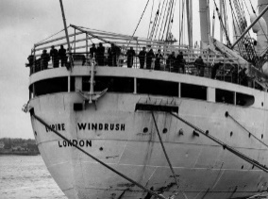
Choosing a Humanities Subject at GCSE.
Read the information carefully to enable you to make a decision about taking History, Geography or both as a GCSE subject! The skills required are quite different. Both GCSEs will challenge you and in both subjects, you will be set weekly ILT that will need to be completed to high standards.
Religious Studies is also part of the suite of Humanities subject, although it does not count towards the EBacc measure. It shares many of the skills and approaches of Geography and History.
A huge amount of commitment is essential for all of your GCSEs and you need to be ready for this!
- For advice with regards to History please ask Miss Adams (Head of History), Mr Harrington or Miss Eldridge.

- For advice with regards to Geography please ask Mr Buckley (Head of Geography), Mr Tait or Miss Eade.

History Specification - AQA  Understanding the Modern World  Shaping the Nation | Geography Specification - AQA.
Why is this course useful? Colleges and universities love people who have studied History because of the skills they learn. You will know how to construct a clear and balanced argument based on fact. You will learn how to express your opinions clearly and debate your ideas with others. We hope you will love history as much as we do!  Paper 1 – Germany, 1890-1945: Democracy and dictatorship and Conflict and tension between East and West, 1945-1972. (84 marks; 2 hour exam)  Paper 2 – Migration, empires and the people: c790 to present and Elizabethan England c. 1568-1603. (84 marks; 2 hour exam) | Why is this course useful? - It provides learners with a solid grounding, whether they are going on to Further Education, Higher Education or the workplace. The qualification aims to inspire a passion for geography within learners, which encourages an interest in the subject, beyond academic achievements, for the rest of their lives.  Paper 1 - Living in the with the physical environment: Natural Hazards, Ecosystems, Rivers and Coast (1hour 30minute exam)  Paper 2 – Challenges in the Human Environment: Urban issues and challenges, Changing economic world, Challenges of resource management and food security (; 1hour 30minute exam).  Paper 3 - Geographical Skills. Topics include cartographic skills, graphical skills, numerical skills and fieldwork skills. (1 hour 15minute exam).

Skills used in History | Skills used in Geography
- Literacy Skills - extended writing requiring a balanced examination of key historical events. This is the majority of your examined work.  - Analysis Skills - interpretation of sources of information which might include quotes, cartoons, historical sites, documentaries, movies and statistics  - Numerical Skills - analysis of statistics including election results or unemployment figures  - ICT Skills - use of computers for independent research  - Revision Skills - there is a huge amount of content to learn and you will need to find a way to remember as much as you can. Every learner is different but you might find mind-maps, timelines and coloured diagrams all useful. | - Cartographic Skills - atlas maps, ordnance Survey maps, cross-sections, physical and human features, photographs, Sketch maps.  - Graphical Skills - graphs, pie charts, pictograms, Sphere of influence.  - Numerical Skills - area, proportion, ratio, interquartile range, percentages, Spearman’s rank correlation coefficient.  - Fieldwork Skills - sequence of enquiry, fieldwork data collection, hypotheses, sampling, data analysis, conclusion, evaluation.  - Literacy skills - Long-answer questions, taking notes for revision, keywords (definitions and spellings).  - ICT Skills - Google Classroom, Quizlet, research tasks, use of Chromebooks.  - Revision Skills - There are 3 exams so a large amount of material to learn. We will discuss in lessons the different ways in which students learn.
Trip opportunities in History | Fieldwork Opportunities in Geography
- Berlin Trip to help further understand both the Germany and Cold War elements of the course  - Historic Environment - Paper 2 requires students to be able to study a place or specific site related to Elizabethan England. Depending on the site set for this year group, we would endeavour to organise a visit there if practical. | Opportunities? Day trips include;  Gloucester to look at Urban landscapes  Blackpool Brook to look at rivers.  Why? In undertaking fieldwork, learners practise a range of new skills, gain new geographical insights and begin to appreciate different perspectives on the world around them. Fieldwork adds “geographical value” to studying, allowing a real life context.

GCSE Geography  AQA GCSE Geography (9-1) 8035 |  |  |  |  | 
What is Involved?
- Instil an interest in different places, the people who live there and the environments they live in, whilst giving learners an opportunity to explore the ever-changing face of geography in the UK.
- Exploring ecosystems of the planet, global development and the people who live on the planet and some of the environmental challenges that the world faces.
- Develop and extend competence in a range of skills including those used in fieldwork, in using maps and Geographical Information Systems (GIS) and in researching secondary evidence.
How are we Assessed? |  |  |  | Grades available: |  | GCSE grades 9-1
- Examination: 100% |  |  | 3 written papers 3 x 1 hour 30 minutes
- be well organised and able to work independently, gather sources, draw conclusions and justify your views
- Carry out fieldwork (expectation that students will attend 2 fieldwork days).
You need to:
 | - Will provide learners with a solid grounding, whether they are going on to Further Education, Higher Education or the workplace. The qualification aims to inspire a passion for geography within learners, which encourages an interest in the subject beyond academic achievements for the rest of their lives.
What it is useful for after Year 11
 | - Mr Buckley or any of the Geography Team.
Who can I speak to about this course?
- log on to the National Careers’ Information Service or KUDOS
- GCSE Textbooks
Where else can I Look?
GCSE History  AQA Understanding the Modern World  Shaping the Nation |  |  | 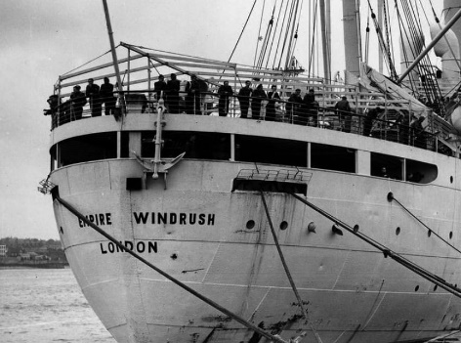
What is Involved?
- The History GCSE involves a study of 1000 years of History, including an in-depth study of 16th century England.
- It also covers international affairs throughout the 20th century, as well as the effects of migration on British society.
- Students will be expected to work independently and be self-motivated to achieve in this academic subject.
How are we Assessed? |  | How are we Assessed?
2 examinations:
Germany and the Cold War - 2 hours, 84 marks (50% of final grade)
Migration, empires and people and Elizabethan England - 2 hours, 84 marks (50% of final grade)

 | - be well organised, committed, able to work independently, gather sources, draw conclusions and justify your views.
You need to:
- A level in History and a wide range of careers.
- University applications

What it is useful for after Year 11
 | - Miss Adams or any of the History team.
Who can I speak to about this course?
 | - log on to the National Careers’ Information Service or KUDOS.
Where else can I Look?

GCSE Religious Studies  OCR J625 |  |  |  |  |  | 
What is Involved?
3 units of work:
- Religion, Philosophy and Ethics in the modern world from a Christian perpective [50%]
- Beliefs, teachings and practices of two religions: Christianity [25%] and Islam [25%]

How are we Assessed? |  |  |  | Grades available: |  |  | GCSE grades 9-1
100% exam. There are three exams altogether.
- Have an interest in the beliefs and cultures of other people.
- Be prepared to discuss and argue.
- Remember this option is not about trying to make you religious!

You need to:
- The qualification will provide a good grounding for any job that requires understanding other people – the Police, Social Workers, teaching, nursing and so on.
- Further academic studies, such as A-Level RS, Philosophy, Politics and Psychology

What it is useful for after Year 11
 | - Miss Barker, Miss McClemont or Mr Mitchell
Who can I speak to about this course?
 | - Log on to the National Careers’ Information Service or KUDOS
Where else can I Look?

Cambridge National  Sport Studies Level 2 – J829 |  |  |  |  | 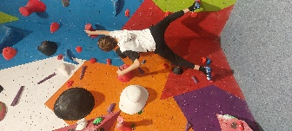  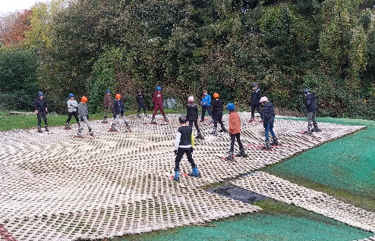
 |  | 3 Units (R184 & R185 Compulsory  Students will study one of R186 or R187 |  |  |  | Grades available:
What is Involved? |  |  |  |  |  | Grades available:
Pass - Distinction*
(Equivalent to GCSE 9-4)

R184: Contemporary issues in sport

R185: Performance and leadership in sports activities

R186: Sport and the media

R187: Increasing awareness of outdoor and adventurous activities
How are we Assessed? |  |  |  | Grades available: |  | Pass - Distinction*  (Equivalent to GCSE 9-4)
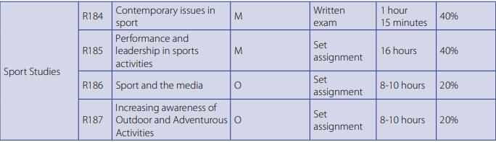
GCSE PE is assessed via practical elements and coursework and two exams. This course is different in that it allows students to put more work in across the two year course towards their final grade. There is less examined content which means this might suit students who do not perform well in exams.
GCSE PE Requires students to be assessed in 3 sports. The Cambridge national asks for students to be assessed in 2 sports and then in one of those as a leader. This might suit students who are struggling to provide high level evidence across 3 sports.
How is the Cambridge National different to GCSE PE?
- be highly motivated and able to meet deadlines
- be able to work independently, accept, give and implement feedback
- be prepared to act as a team player, participant, leader and official.
You need to:
 | - Cambridge Technical In Sport - Careers in many aspects of Sport.
What it is useful for after Year 11
 | - Mr P Griffiths or any of the PE Department
Who can I speak to about this course?
 | - Log on to the National Careers’ Information Service or KUDOS sportsengland.org.uk/careers or careers-in-sport.co.uk
Where else can I Look?
GCSE PE  OCR J587 |  |  |  |  |  | 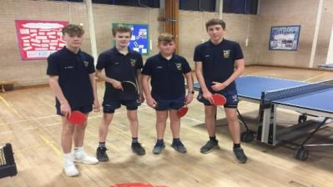
 |  |  |  |  | 4 main aspects:
What is Involved in GCSE PE?
- Theory
  - Applied Anatomy & Physiology
  - Socio- Cultural Influences & Sports Psychology. Health, Fitness and Well-being
- Practical – National curriculum courses e.g. rugby, netball, badminton, tennis plus Junior Sports’ Leaders and sports that students do outside school on the syllabus
- Analysis of Performance – project and interview
- Personal Exercise Plan – Coursework; 6 week plan.
How are we Assessed? |  |  |  | Grades available: |  |  | GCSE grades 9-1
- Examination:  - Controlled Assessment: |  | 60%  40% |  | 2x 1hr– Theory of Physical Education- Exam Papers  Three practical sports + Analysis of performance
- be highly motivated and able to meet deadlines
- be able to work independently, accept, give and implement feedback
- be prepared to act as a team player, participant, leader and official.
You need to:
 | - A level Physical Education - Careers in many aspects of Sport.
What it is useful for after Year 11
 | - Mr P Griffiths or any of the PE Department
Who can I speak to about this course?
 | - Log on to the National Careers’ Information Service or KUDOS sportsengland.org.uk/careers or careers-in-sport.co.uk
Where else can I Look?

GCSE Music  OCR Level 1/2 GCSE in Music (J536) |  |  |  |  | 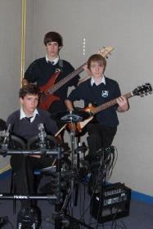
What is Involved?
3 units, 5 Areas of Study:
Area of Study 1: My Music
Area of Study 2: The Concerto Through Time
Area of Study 3: Rhythms of the World
Area of Study 4: Film Music
Area of Study 5: Conventions of Pop
How are we Assessed? |  |  |  | Grades available: |  | GCSE grades 9-1
- Performance on the learner’s chosen instrument. Composition to a brief set by the learner. Choose 1 = 30% - Coursework
- Ensemble performance. Composition to an OCR set brief. Choose 1 – 30% - Coursework
- Listening and Appraising. A written paper, with CD. Aural recognition and context unheard/unfamiliar music from within the Areas of Study 2, 3, 4 & 5 = 40% - External Exam.

- be able to work independently, accept and implement feedback.
- be having instrumental lessons, ideally, to improve your musical skills and understanding
You need to:
 | - A Level Music / Music Technology.
What it is useful for after Year 11
 | - Miss Burt
Who can I speak to about this course?
 | - log on to the National Careers’ Information Service or KUDOS.
Where else can I Look?

GCSE Design and Technology  Textiles  Edexcel 1DT0 |  |  |  |  |  |  | 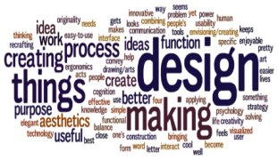
 |  |  |  | This course allows students to specialise in Textiles but also has a common core of materials, processes and technologies that everyone needs to know. Students can also choose Catering with this course.
What is Involved?
A wide range of activities based on designing & making products. These are taught through practical work, supported by written work. Problem solving, designing and making products are at the heart of this course still with a coursework element but with an increased emphasis on a terminal exam.
How are we Assessed? |  |  |  |  |  | Grades available: |  | GCSE grades 9-1
- Examination:  - Coursework: | 50%  50% |  | Specialised Knowledge of the chosen material area + knowledge of the core topics for everyone to study with industrial processes.  A themed Design and Make Activity set annually by the exam board taken in year 11 by the students.
- complete coursework in school with teacher supervision
- be enthusiastic, organised and committed as well as work independently.
- choose one specialised area of materials to study
- enjoy being creative and applying practical skills to make quality products.
You need to:
 |  | - A levels in Product Design or Fashion & Textiles / BTEC courses. Employers appreciate the problem solving and technical skills developed.
What it is useful for after Year 11
 |  | - Either Mr Adams or Mrs Adams (Textiles)
Who can I speak to about this course?
- log on to the National Careers’ Information Service or KUDOS
- https://qualifications.pearson.com/en/qualifications/edexcel-gcses/design-and-technology-2017.html
Where else can I Look?

Technical Award in Product Engineering – Level 1/2  EDUQAS 5799QA |  |  |  |  | 
What is Involved?
Interpret Engineering information and plan how to make products, Develop Knowledge, Understanding and Skills in using a range of tools and equipment to make products. Explore how products are adapted and improved. Know how Engineering Design has had an impact on modern day life at home, work and society in general
How are we Assessed? |  |  |  | Grades available: |  | Pass – Distinction (Equivalent to GCSE 9-1)
Unit 1 – 40% - Manufacturing Engineering Products
Unit 2 – 20% - Designing Engineering Products
Unit 3 – 40% - Solving Engineering Problems (Examination)
- Enjoy being creative and applying practical skills to make quality products.
- Be enthusiastic, organised and committed as well as work independently and in teams.
- Complete coursework with teacher supervision.

You need to:
- A levels in Product Design or Fashion & Textiles/BTEC courses
- Employers appreciate the problem solving and technical skills developed.
What it is useful for after Year 11
 | - Mr Adams, Head of Design and Technology.
Who can I speak to about this course?
- log on to the National Careers’ Information Service or KUDOS, Eduqas Engineering.
- Technical Award web page: https://eduqas.co.uk/umbraco.surface/blobstorage/download?nodeld=38020
Where else can I Look?

Frequently Asked Questions

Will I get my first choice subjects?
You are asked to select five preferences. You should be prepared to be allocated any of these five. We will always try and give students their highest priorities first, however, this cannot be guaranteed. In the rare instance where we are unable to allocate four subjects from the five preferences, we will always speak to the student directly.

Can I change subjects in Year 10?
Changing subjects after the course has started is not recommended. You should aim to find out as much information as possible about the course you are selecting and be fully committed to it from the outset. In our experience when students change courses this has a serious impact on their chances of success.

Can I choose more than one subject from the same subject area?
Please bear in mind our advice about creating a broad and balanced curriculum. The way the form is set out should encourage you to meet that aim. However, we do know that each student is different and that some students will wish to study more than one subject from each area. This may be possible, but there may also be restrictions within the timetable for certain subject combinations. You can discuss this with your subject teachers further if you have any questions.

Do I have to study a language?
The expectation is that most students will study a language, so that they can achieve their EBacc qualification.

Do I have to study a Humanities subject?
Our expectation is that all students will study either History and/or Geography.

Can I study two Humanities?
Yes.

I am finding it difficult to fill out the form, is there anywhere we can get support?
Of course. Your daughter/son will have met with his/her tutor and gone through some of the things they should be thinking about. However, we are aware that this can be a daunting task. Please contact the school in the first instance and we can set up help as it is needed.

What is the difference between a ‘GCSE’, ‘Technical Award’ and ‘Cambridge National’
Each of these courses will lead to equivalent qualifications, with the full range of outcomes being available. The Technical Award and Cambridge National are courses that are designed to have more coursework based activities and are used for delivering practical subjects.
Completing Your Options’ Form
Do not rush your form or leave it to the last minute. How you fill out this form will affect what you do for the next two years, so it is important that you complete it accurately and thoughtfully.

It seems obvious, but do double check that you have put your name and tutor group on your form.
You DO NOT need to make any choices for your ‘core’ courses.
This extra information will help us in coaching your daughter/son through the process
Insert the numbers 1-5 in order of preference

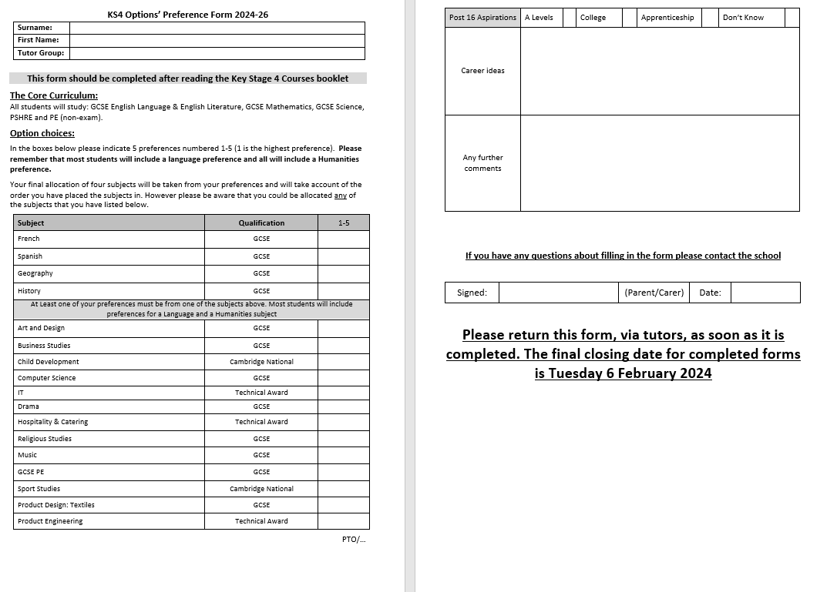

The form must be handed in to Tutors. The deadline gives you plenty of time to think about and discuss different ideas. You are asked to return the form as soon as you are happy with your choices, however, you must meet the deadline on the form. If you do not meet this deadline, it may mean that you cannot study the courses that you have requested.

