**When you answer questions in geography remember the PEEL technique**

[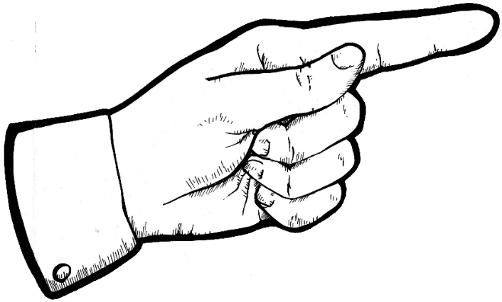](http://www.google.co.uk/url?sa=i&source=imgres&cd=&cad=rja&uact=8&ved=0CAgQjRwwAGoVChMIt_7Hy8LfxgIVSF4eCh2LFQGi&url=http://cliparts.co/clip-art-finger&ei=3JGnVbegO8i8eYurhJAK&psig=AFQjCNGqIB3SR-l07-dGUQSz4hkrQrZqMw&ust=1437131613082036)

**P Make your POINT**

[](http://www.howtobecome.com/how-to-become-a-detective)

**E Give your EVIDENCE**

[](http://www.google.co.uk/url?sa=i&source=imgres&cd=&cad=rja&uact=8&ved=0CAgQjRwwAGoVChMIqt-ejMTfxgIVwnYeCh2V4w3L&url=http://www.toiirvin.com/you-are-as-unique-as-your-fingerprints/&ei=cZOnVeriAsLteZXHt9gM&psig=AFQjCNGmmivwl3tCwW2vx56M4PskzSi_vA&ust=1437132017153592)

[](http://www.google.co.uk/url?sa=i&source=imgres&cd=&cad=rja&uact=8&ved=0CAgQjRwwAGoVChMIqt-ejMTfxgIVwnYeCh2V4w3L&url=http://www.toiirvin.com/you-are-as-unique-as-your-fingerprints/&ei=cZOnVeriAsLteZXHt9gM&psig=AFQjCNGmmivwl3tCwW2vx56M4PskzSi_vA&ust=1437132017153592)

**This is because…**

**E EXPLAIN your evidence**

[](http://www.google.co.uk/url?sa=i&source=imgres&cd=&cad=rja&uact=8&ved=0CAgQjRwwAGoVChMIzvO2nb_fxgIVyiYeCh0I_QbC&url=http://www.ipad-aed.com/wp-content/uploads/2014/04/&ei=Vo6nVc7wN8rNeIj6m5AM&psig=AFQjCNFtVo3SfQVYeEauo8Jw6_SfLvWkgw&ust=1437130710995852)

**L If possible, LINK to your next statement or the original point.**

WHERE ARE YOU?...

What do you need to focus on to improve your long answer questions?

(Basic  Clear  Detailed)

Write down 3 key targets you need to focus on to improve your work.